Gambia Agricultural Investment Plan - GNAIP (Gap Financing)

£

Declaration by the Government and LCG on Agriculture, Rural Development and Food Security:

This Document has been prepared by the Government of The Gambia and endorsed by the Ministry of Agriculture and Chair of Development Partners in The Gambia.

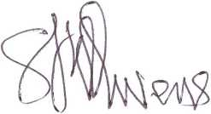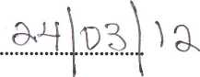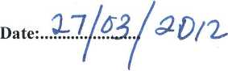

Honourable Solomon Owens

Minister, Ministry of Agriculture

Ms Chinwe Dike

Chair of Development Partners

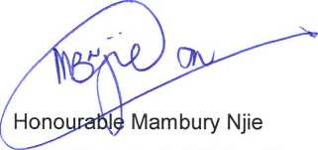

Minister, Ministry of Finance and Economic Affairs, Government of The Gambia

**Date:..,**

